**Information System Management Lab**

**BCOM 307**

**Assignment #8**

***Submitted by:***

**Name:** YASH JAIN

**Enrollment No:** 03914788818

**Semester:** B.Com(H) 5th Semester

**Class:** B.COM(H)

**Section:** B.Com 5A

**Date of Submission:** 01/10/2021

***Submitted to:***

**Praveen Kumar Singh**

**Assistant Professor, MAIMS**



**Department of Commerce**

**Maharaja Agrasen Institute of Management Studies**

**Affiliated to Guru Gobind Singh Indraprastha University, Delhi**

**Sector -22, Rohini, Delhi -110086, India; www.maims.ac.in**

Maharaja Agrasen Institute of Management Studies

Affiliated to GGS IP University; Recognized u/s 2(f) of UGC Recognized by Bar Council ofIndia; ISO 9001: 2015

Certified Institution Sector 22, Rohini, Delhi -110086, India; [www.maims.ac.in](http://www.maims.ac.in/)

Department of Commerce

Academic Year: 2020-21

Semester: Vth

# Assignment No.8

# Unit No:

**Course/Subject Code:** BCOM 307 **Subject Title: Information System Management Lab**

# Issue Date: Last Date of Submission:

**Instructions for Students:**

# All Questions are Compulsory.

1. The student should attach proper cover page for each assignment clearly mentioning the Assignment No.
2. Each assignment should be prepared by the student individually with proper explaination and screenshots.
3. A4 size ruled sheets should be used for the assignment.
4. Assignment pages should be serially numbered at the bottom of page.

***During online education mode, upload scanned copy of the complete assignment including cover page latest by due date.***

|  |  |  |
| --- | --- | --- |
| **Question No.** | **Question** | **CO No.** |
| 1 | Update the city to Mumbai of client with client ID 101. | **CO1** |
| 2 | Update the baldue to 10,000 of all clients belonging to Mumbai from the client_master table. |
| 3 | Update the baldue to 10,000 for all the clients. |
| 4 | Insert a new row in client_master table. |
| 5 | Increase the baldue of all clients by 10% in the client_master table. |
| 6 | Display distinct city name in client_master table. |
| 7 | Delete record from client_master where baldue is less than 10,000. |

**ASSIGNMENT 8 - UPDATE COMMAND**

**Task 1 : Update the city to Mumbai of client with client ID 101.**

The following task is completed using the **‘update’** command, along with the **‘SET’** keyword, and the **‘where’** clause. The ‘update’ command is used to update records from table. It is used to change / modify data values in a table. We can update all records and/or specific records. The ‘set’ keyword is used after update command, to modify the data values. The syntax for this is:

Update <tablename> SET column_name=value;(for modifying all records)

Update <tablename> SET column_name=value where <condition>;(for modifying specific records)

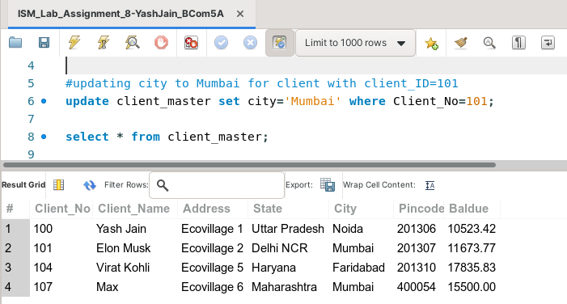

**Task 2: Update the baldue to 10,000 of all clients belonging to Mumbai from the client_master table.**

The following task is completed using the **‘update’** command, along with the **‘SET’** keyword, and the **‘where’** clause.

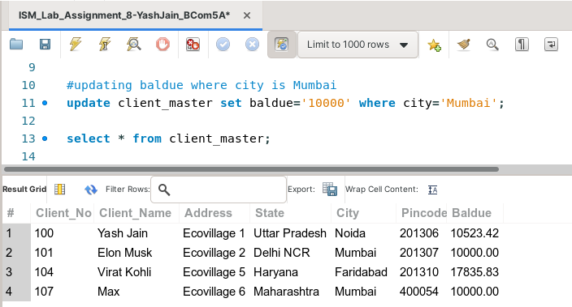

**Task 3: Update the baldue to 10,000 for all the clients.**

This task can be completed using the **‘update’** command along with the **‘SET’** keyword.

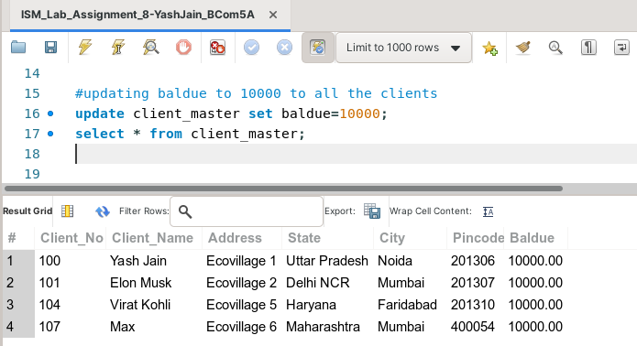

**Task 4: Insert a new row in client_master table.**

This task can be completed using the **‘insert into’** command, along with the **‘values’** keyword.

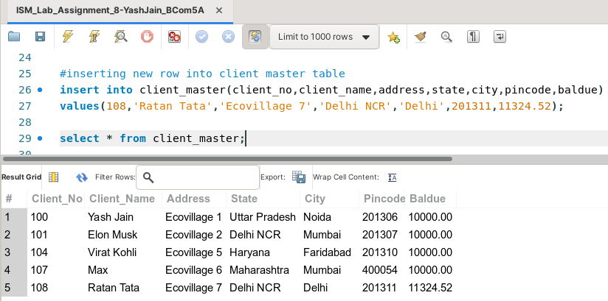

**Task 5: Increase the baldue of all clients by 10% in the client_master table.**

This task can be completed using the **‘update’** command, with the **‘SET’** keyword.

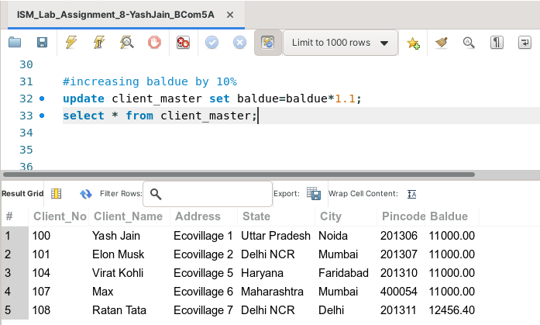

**Task 6: Display distinct city name in client_master table.**

This task can be completed using the **‘select’** command along with the **‘distinct’** keyword.

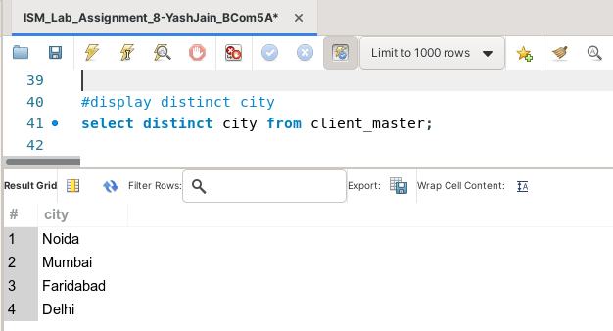

**Task 7: Delete record from client_master where baldue is less than 10,000.**

This task can be completed using the **‘delete from’** command, along with the **‘where’** clause.

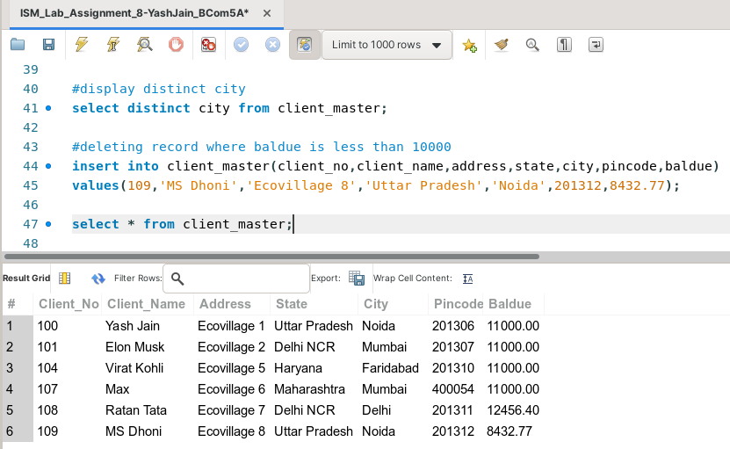.

(before deletion)

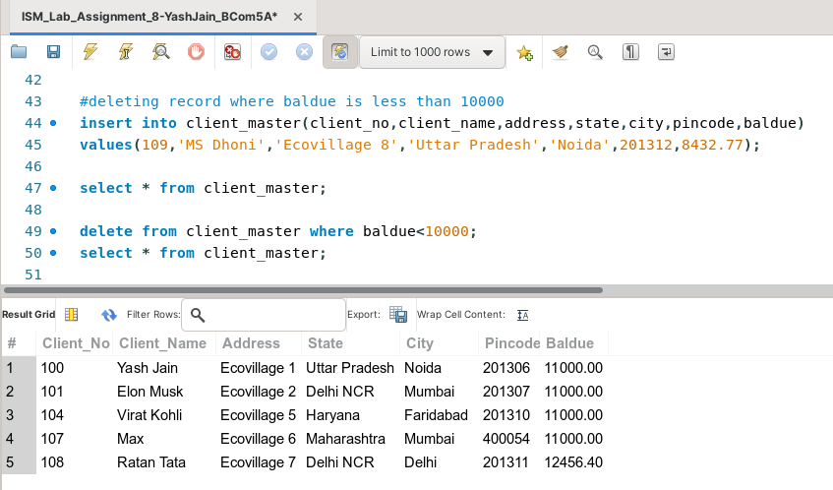

(after deletion)